DataBricks Earthquake Analysis Project

Objective: Setup connection in DataBricks to pull earthquake api data and perform an analysis on the data from raw to gold layer. Using an automated pipeline and delta lake features, this project showcases from start to finish, the process of pulling raw api data, generating a schema, cleaning and transforming the data and ultimately giving the business real world, up to date information to analyze.
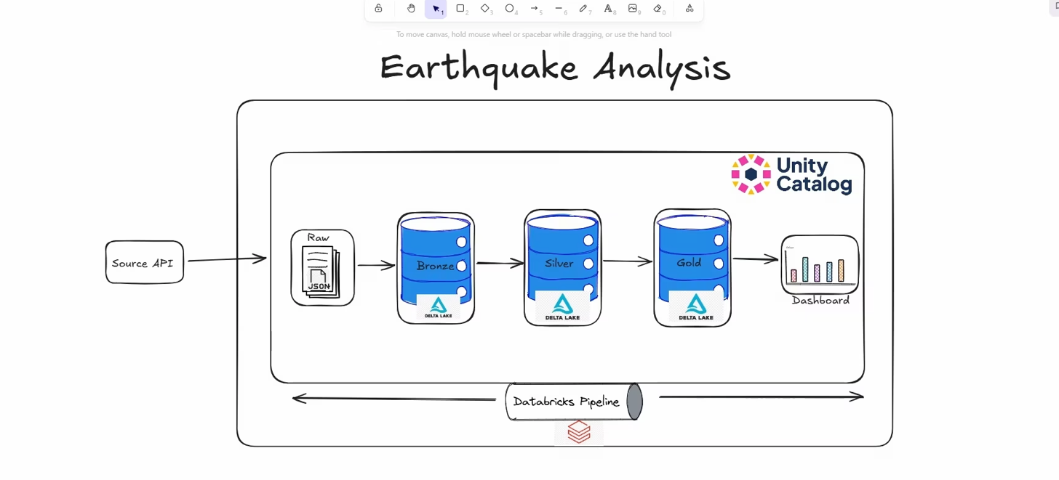

Process: Part 1 of this project is the creation of all notebooks in Databricks for raw ingestion, bronze layer, silver layer, gold layer and finally a dashboard. This is all then run through a job created to run on a schedule through all the layers with updated API information.
Part 2 of this project is the same process but run through the DataBricks Pipeline to showcase the ability of Spark Declarative Pipelines (SDP). The benefit of doing SDP allows more automation of ETL development, reduces code complexity and improves performance.
In the first picture is the full detailed pipeline. The final materialized view shows the final data with incremental changes each time the pipeline is run with updated API information.
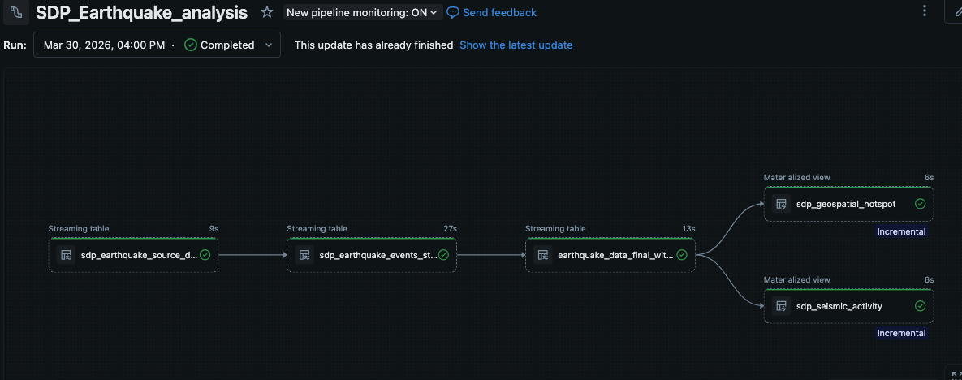

Here is one final job created to run the API ingestion and then run the pipeline.
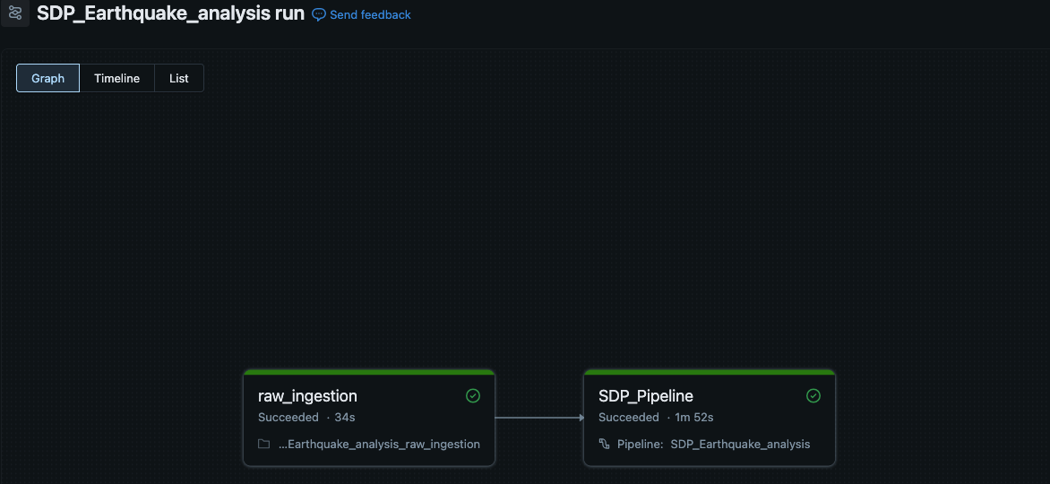

Here is the final Unity Catalog. You can view both the regular tables and the SDP tables created, side by side.

